# Design Document

* Each player has an HQ building and a finite resource patch which must be gathered.
* They start with 5 workers who can gather resources.
* Units can traverse white areas that don’t have buildings or resources
* The passages between the bases only one unit at a time
* Units and buildings cost resources to be gathered by workers
* HQ is limited to one
* Buildings can only be built on available slots
* Expansion allows another resource gathering spot

## Project

* C++ in Visual Studio 2015
* Use SFML for displaying graphics and outputting results
* <http://www.sfml-dev.org/>

## Pseudocode

While running

Update player

Update buildings

Update units

If less than 10 workers

Check if a worker has finished training

If not training worker start training if affordable

Else

Check if a warrior has finished training

If not training warrior start training if affordable

Increase money based on number workers

Render all objects

## AI Actions

|  |  |
| --- | --- |
| **Target** | **Action** |
| Any Unit | Attack |
| Any Unit | Move |
| Worker | Gather |
| Building | Train new unit |
| Building | Start research |
| Building slot | Build building |

There are a limited number of actions the AI can take. When issued an attack command, they can only attack from a base location to the nearest base. Attacking happens every second. If opposing units are gathering in a base all units will attack at once in a big melee.

## Basic Rule AI

This is for the basic map

* Build queue
* Build X number of workers then begin to build warriors
* At X number of warriors, issue attack order
* Keep building warriors

## Genetic AI

This will be able to carry out any of the AI actions available. Uses the genetic algorithm iteration to try to learn how to play. I will add more complexity to the game as the algorithm is able to beat or at least stalemate the rule based AI.

## First Version

### Map

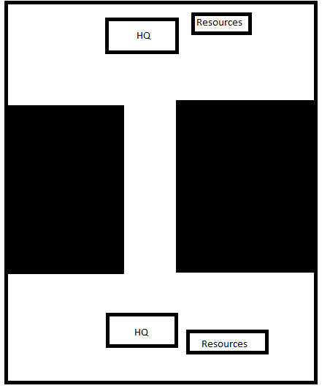

### Units

Both units are trained from the HQ

|  |  |  |  |  |
| --- | --- | --- | --- | --- |
| **Unit Name** | **Health** | **Speed** | **Damage** | **Special** |
| Worker | Low | Medium | Low | Can gather resources |
| Warrior | Medium | Medium | Medium | None |

## “Final” Version

### Map

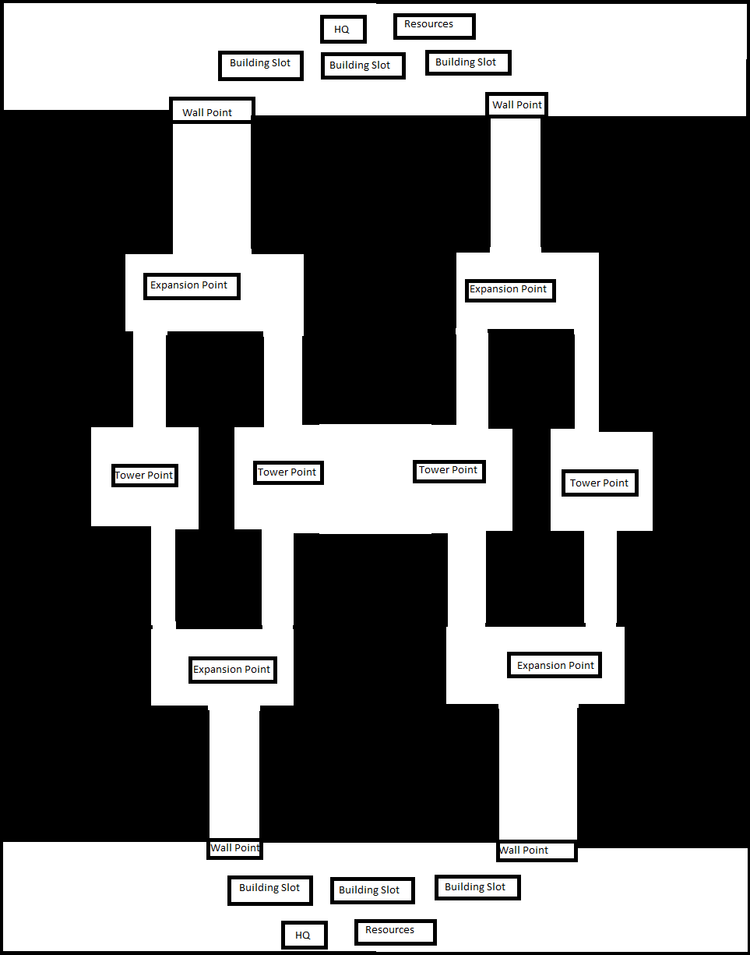

### Units

|  |  |  |  |  |  |  |
| --- | --- | --- | --- | --- | --- | --- |
| **Unit Name** | **Health** | **Speed** | **Damage** | **Special** | **Requirement** | **Building** |
| Worker | Low | Medium | Low | Can gather resources | None | HQ |
| Warrior | Medium | Low | Low | None | None | Barracks |
| Spearman | Medium | Low | Medium | Good versus stable units | Barracks Technology | Barracks |
| Swordsman | High | Low | Medium | Expensive | Barracks  Technology | Barracks |
| Archer | Low | Medium | Low | Can attack targets at range | None | Archery Range |
| Crossbowman | Low | Medium | High | Can attack targets at range  Expensive | Archery Range Technology | Archery Range |
| Horseman | Medium | High | Medium | Cavalry | None | Archery Range |
| Knight | High | High | High | Very Expensive  Cavalry | Stables Technology | Stables |
| Catapult | Low | Low | Low | Can attack targets at range  Deals bonus damage to buildings | Archery Range Technology | Archery Range |

### Buildings

|  |  |  |  |
| --- | --- | --- | --- |
| **Name** | **Builds** | **Special** | **Requirement** |
| HQ | Workers  Catapult | If this is destroyed, you lose  Building Upgrades | None |
| Barracks | Warriors  Swordsman  Spearman | Infantry Upgrades | None |
| Archery Range | Archer  Crossbowman  Catapult | Archery Upgrades | Barracks |
| Stables | Horseman  Knight | Cavalry Upgrades | Archery Range |
| Expansion | Nothing | Can gather more resources here with workers | None |
| Walls | Nothing | Blocks Enemy Units  Can be upgrades with towers | Fortification Upgrade |
| Tower | Nothing | Shoots Enemy units | Tower Upgrade |

### Technology

|  |  |  |  |
| --- | --- | --- | --- |
| **Name** | **Building** | **Requirement** | **Unlocks** |
| Advanced Research | HQ | Stables | Late game units |
| Fortification | HQ | None | Walls |
| Towers | HQ | Fortification  Advanced Research | Towers |
| Spears | Barracks | None | Spearman |
| Swords | Barracks | Spears  Advanced Research | Swordsman |
| Crossbow | Archery Range | None | Crossbowman |
| Ballistics | Archery Range | Crossbows  Advanced Research | Catapults |
| Feudalism | Stables | Advanced Research | Knights |